File Sharing on DHCP Network

Topology

Router Configuration

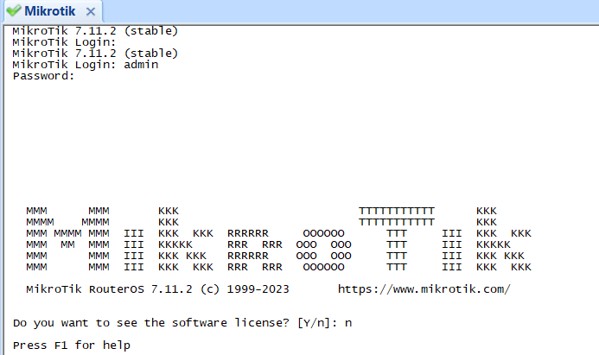

Mikrotik Login (username: admin; password: )

Change Password

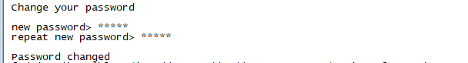

Figure: Mikrotik Password Change

Interface IP, Address, IP Pool and DHCP Configuration

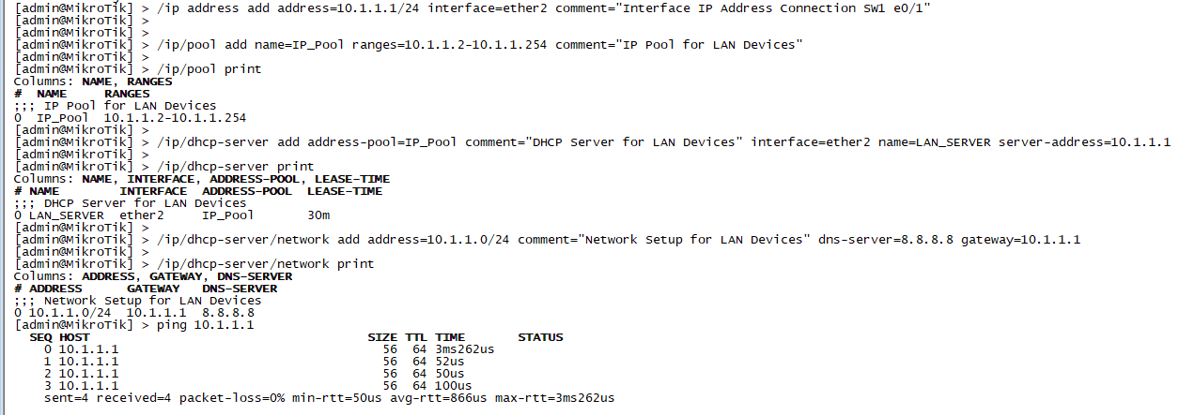

Figure: DHCP Server

Network Address Translation



Figure: NAT

Ping: Check Some IP Address

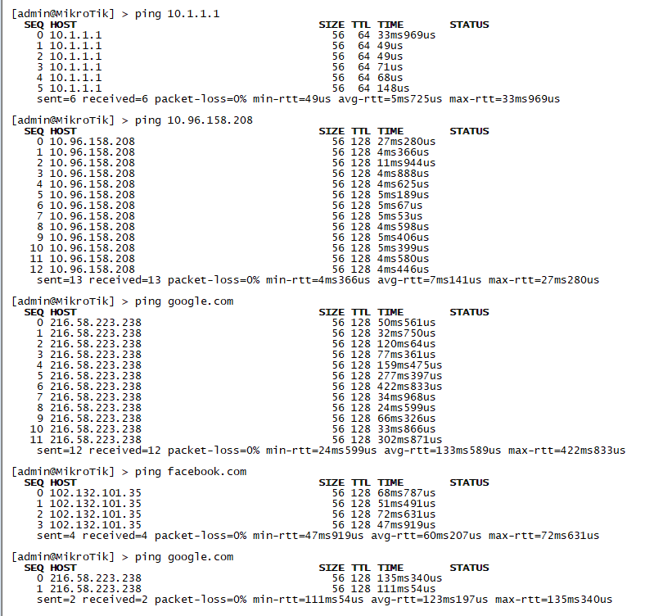

Figure: Ping Check to Internal and External IP address

Main Configuration

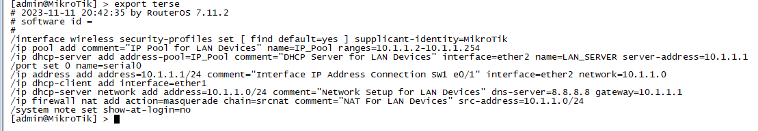

Figure: Main Config

Step to configure on PC using window 7

Computer Name: PC1

WORKGROUP:

Create a folder and add file into the folder

Click on property goto share and set sharing policy

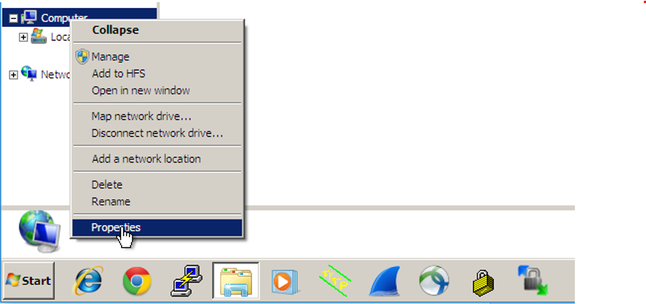

Figure: System Properties

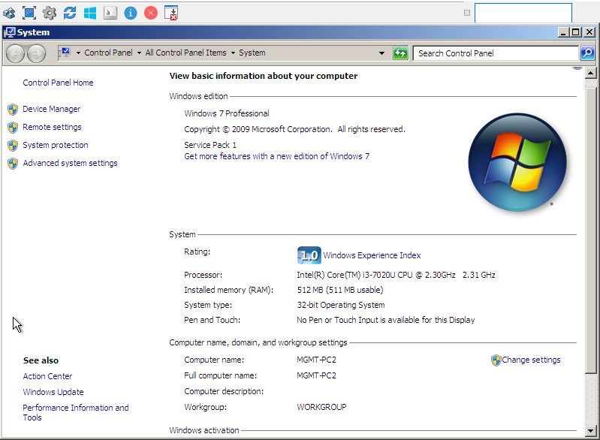

Figure: System Information

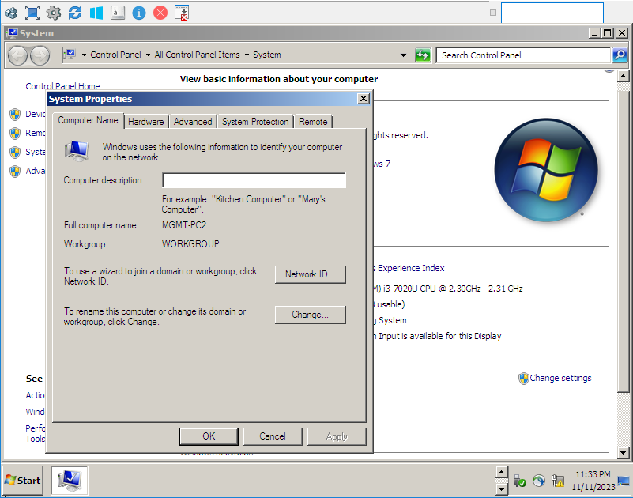

Figure: System Properties

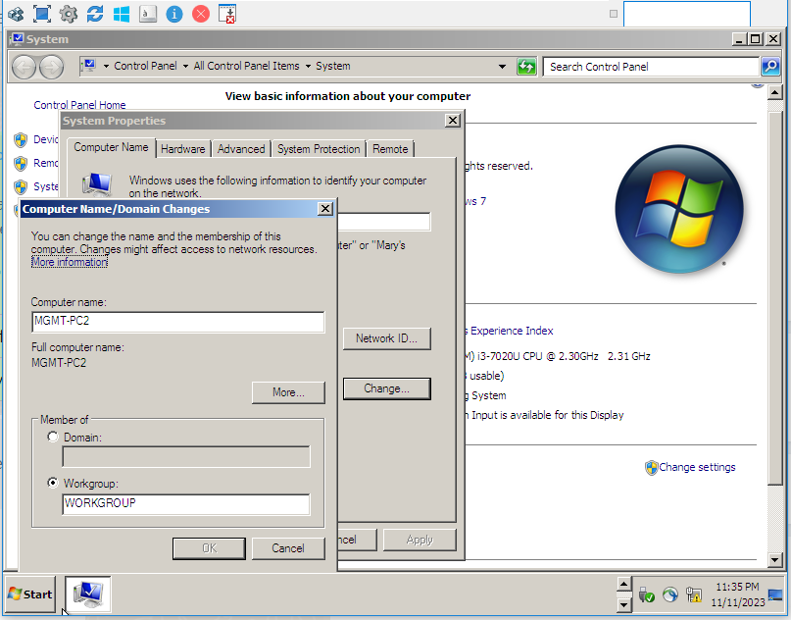

Figure: Computer Name Change

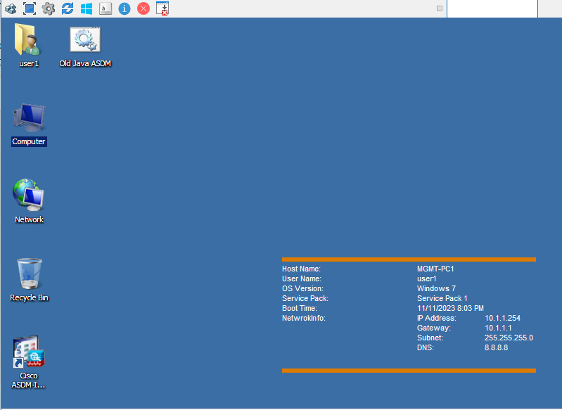

Figure: System Desktop Page

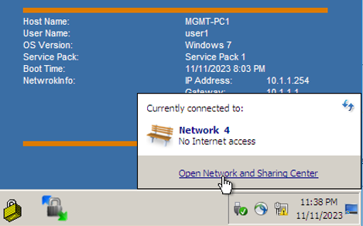

Figure: Open Network Interface

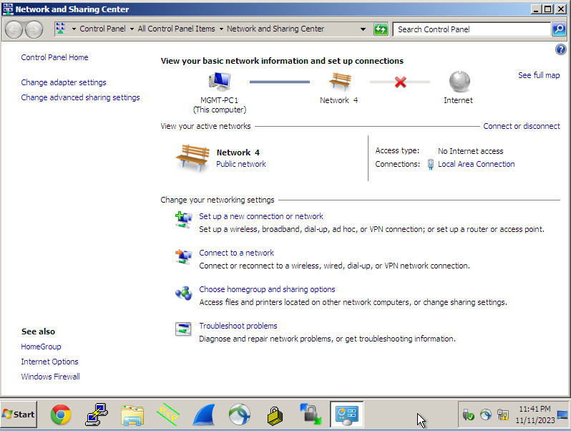

Figure: Network Sharing Center

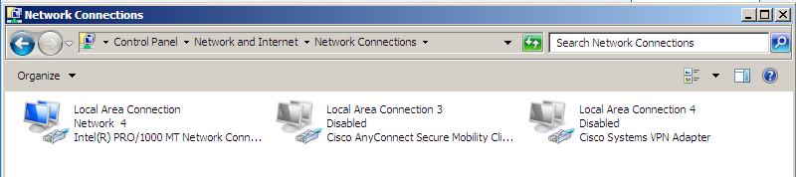

Figure: Network Connection

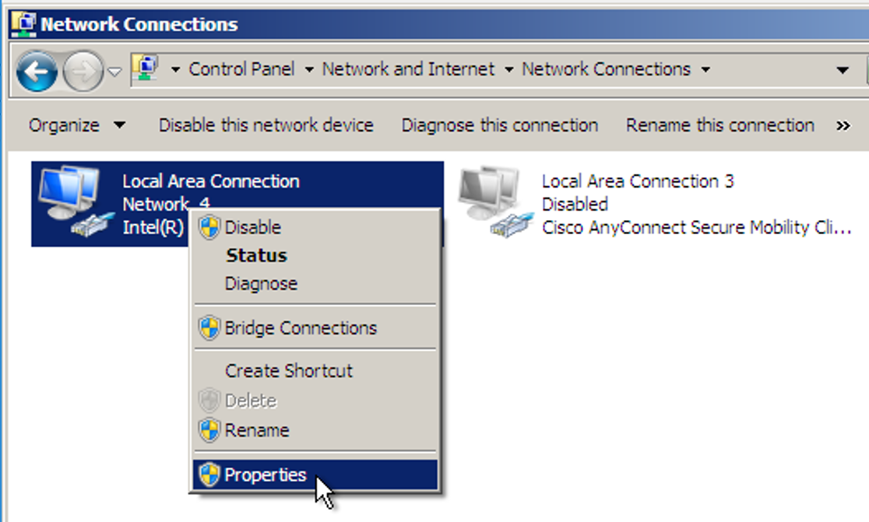

Figure: Local Area Connection (LAC) Properties

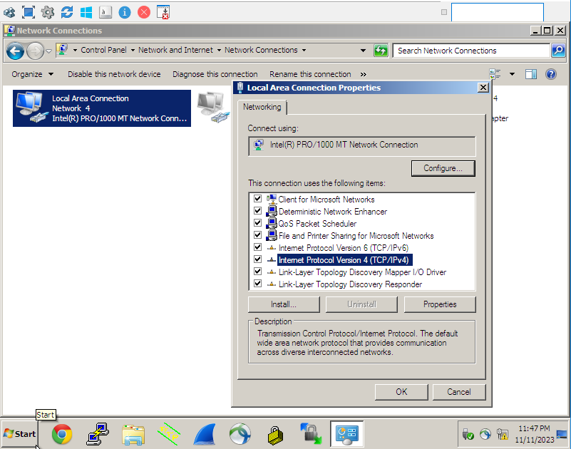

Figure: IPv4 Properties

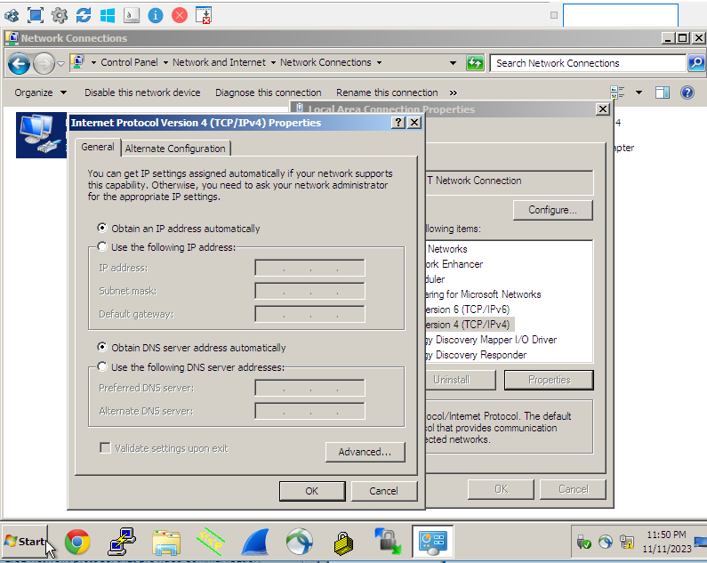

Figure: IPv4 Set Auto

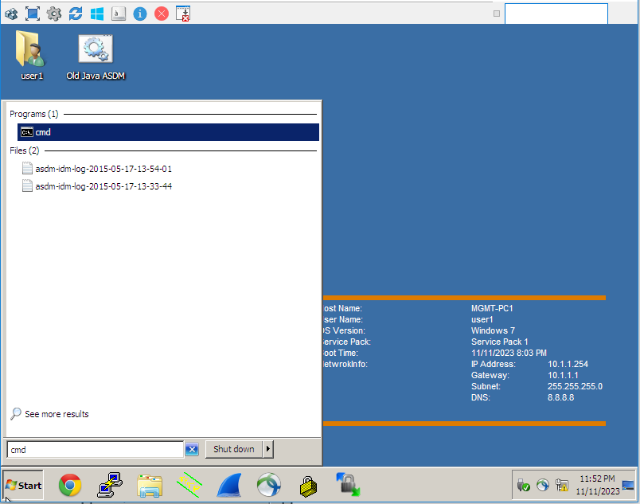

Figure: CMD IP Config Test

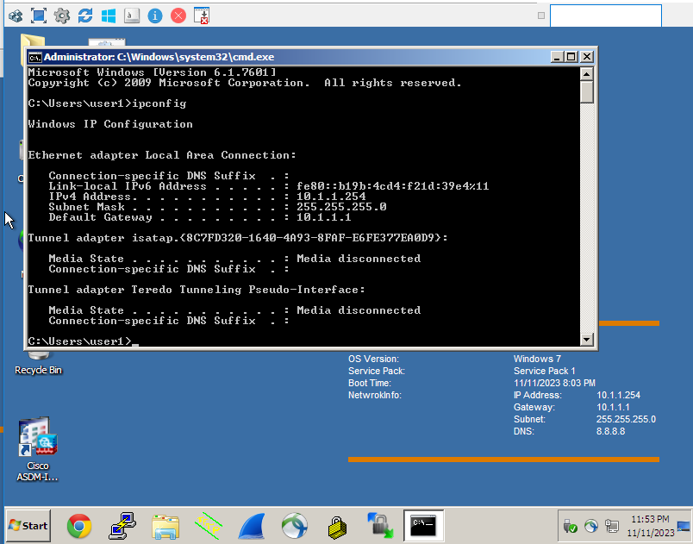

Figure: IP Config Checked

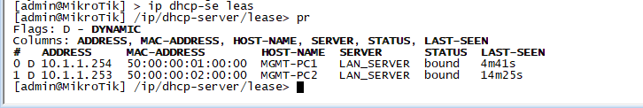

Figure: Ckeck IP lease on Mikrotik